# C2- S4-PRACTICE

*NOTE: check your* ***THEORY slides*** *to answer those questions!*

# EXERCISE 1 – BOOK & AUTHORS

We want to manage books and authors:

* A book has always 1 author only
* An author could write many books.

|  |
| --- |
| **Author** |
| authorID |
| name |
| dateOfBirth |
| country |

|  |
| --- |
| **Book** |
| bookID |
| Title |
| publishYear |
| language |

**Q1** – What is the relation between Book and Author tables? Why?

The relation between Book and Author tables is one to many. Because one author can write many books but one book can be written by only one author.

* + Complete the missing attributes or table to allow this relation

|  |
| --- |
| **Book** |
| bookID |
| Title |
| publishYear |
| language |
| authorID |

1 many

|  |
| --- |
| **Author** |
| authorID |
| name |
| dateOfBirth |
| country |

**Q2** – For each table, complete the following arrays, by specifying for each attribute:

* + The field type (SQL type) and size
  + Can be null or not?
  + Is a primary key or foreign keys?

**AUTHOR TABLE**

|  |  |  |  |
| --- | --- | --- | --- |
| Attribute name | Type / size | Can be Null? | Key |
| authorID | INT | NO | PRIMARY KEY |
| name | VARCHAR(200) | NO |  |
| dateOfBirth | DATE | NO |  |
| country | VARCHAR(200) | NO |  |

**BOOK TABLE**

|  |  |  |  |
| --- | --- | --- | --- |
| Attribute name | Type / size | Can be Null? | Key |
| bookID | INT | NO | PRIMARY KEY |
| Title | VARCHAR(200) | NO |  |
| publishYear | DATE | NO |  |
| language | VARCHAR(200) | NO |  |
| authorID | INT | NO | FOREIGN KEY |

**Q3** – Write the SQL statement to create the 2 tables with appropriate properties

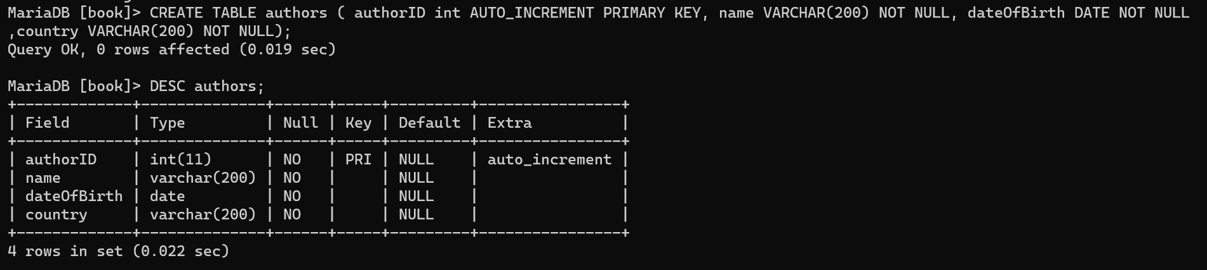

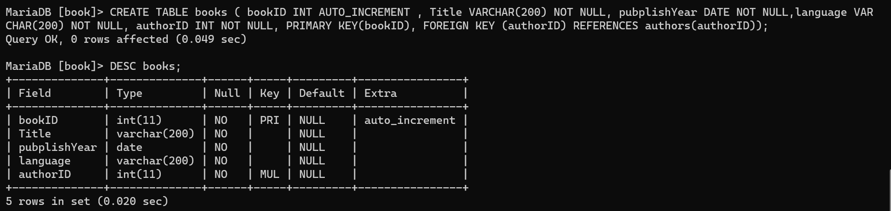

**Q4–** Write the statement to insert 5 books and 5 authors

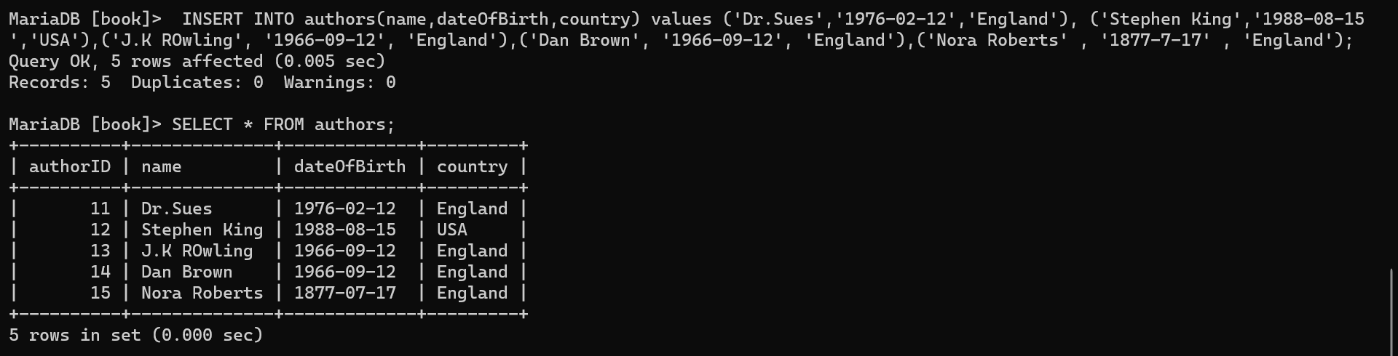

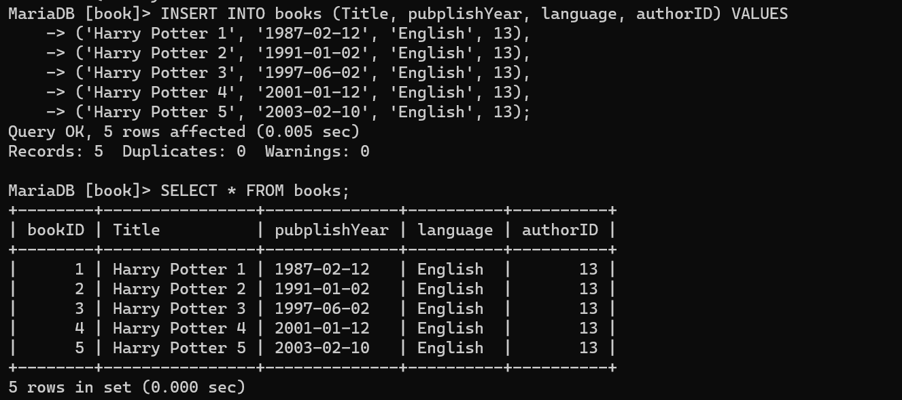

* + Find the book and author information on the Internet

**Q5–** Write the SQL statement to **delete 3 of your books** from the database

# 

# EXERCISE 2 – USERS & POSTS

We want to manage **users** and **posts** (like posts on Facebook)

* A post is related to **1 user only**
  + A post has a body (the text of the post)
* User can have **many posts**
  + A user has a first name, and a nick name (optional)

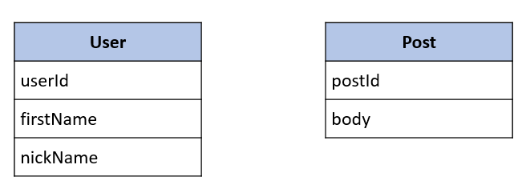

**Q1** – What is the relation between User and Post Table?

The relation between User and Post Table is One to many.

* + Complete the missing attributes or table to allow this relation

|  |
| --- |
| **User** |
| userID |
| firstName |
| nickName |
|  |

|  |
| --- |
| **Post** |
| postID |
| body |
| userID |

1 many

**Q2** – For each table, complete the following arrays, by specifying for each attribute:

* + The attribute type (SQL type) and size
  + Can be null or not?
  + Is a primary key or foreign keys?

**USER TABLE**

|  |  |  |  |
| --- | --- | --- | --- |
| Attribute name | Type / size | Null? | Key |
| userID | INT | NO | PRIMARY KEY |
| firstName | VARCHAR(200) | NO |  |
| nickName | VARCHAR(200) | YES |  |

**POST TABLE**

|  |  |  |  |
| --- | --- | --- | --- |
| Attribute name | Type / size | Null? | Key |
| postID | INT | NO | PRIMARY KEY |
| Body | VARCHAR(400) | NO |  |
| userID | INT | NO | FOREIGN KEY |

**Q3** – Write the SQL statement to create the 2 tables with appropriate properties

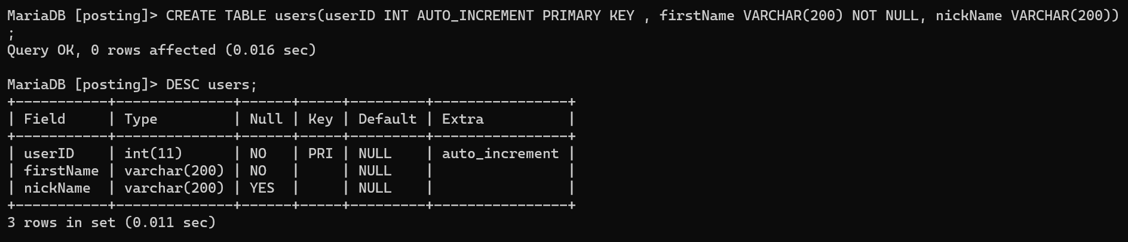

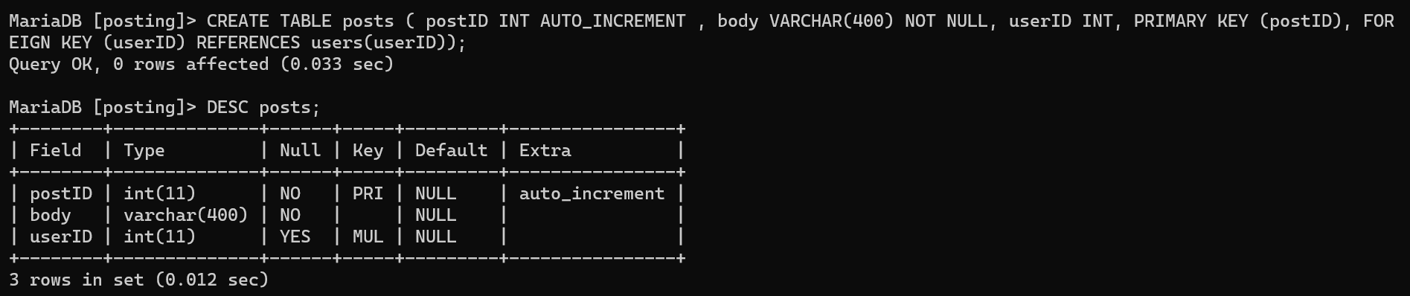

**Q4–** Write the statement to insert the following users and posts

Notes:

* ---- means: no value (the nickname is optional!)
* We don’t specify the KEY, it’s your business!

**USERS**

|  |  |
| --- | --- |
| First name | Nick name |
| Ronan | roro |
| Sokea | ---- |
| Edouard | doudou |

**POSTS**

|  |  |
| --- | --- |
| Post body | From |
| Hello all ! | Ronan |
| I like rice | Ronan |
| YES YES | Sokea |

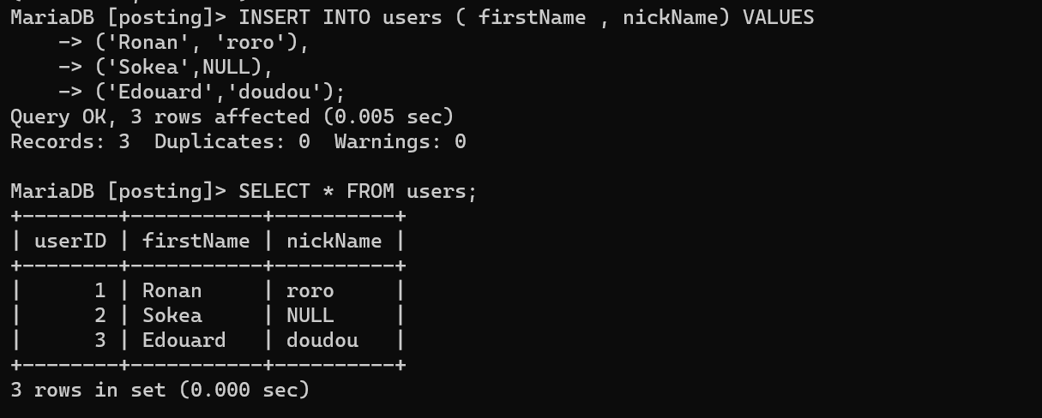

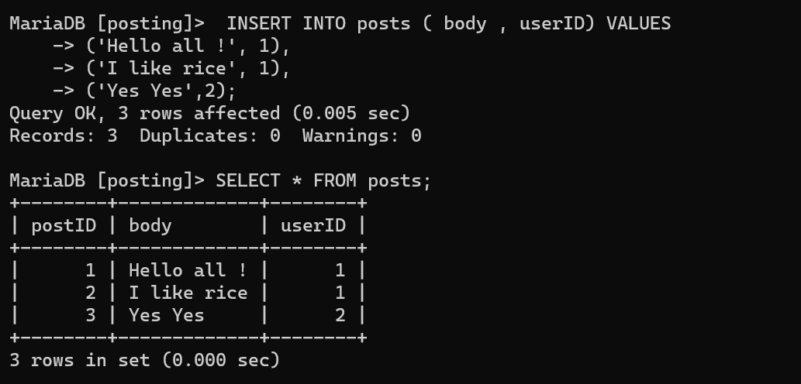

**Q5–** Write the statement to delete the user Edouard

* What’s happen? Can we delete it? Why?
* It’s disappeared. We can delete it because it is the record of users table.

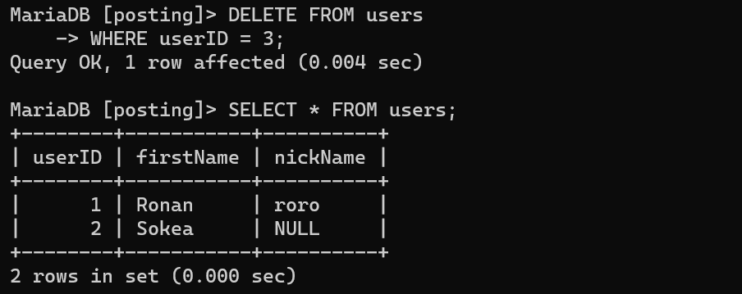

**Q6–** Write the statement to delete the user Ronan

* What’s happen? Can we delete it? Why?
* We cannot delete it because it’s the foreign key of posts table so we cannot update or delete it.



**Q7–** Write SQL statement to remove the rows related to Ronan user:

* Hello all!
* I like rice

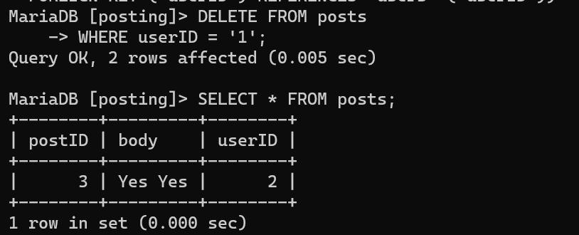

**Q8–** now try again to delete the user Ronan

* What’s happen? Can we delete it? What can you conclude?
* It’s disappeared. Because it is not the foreign key of the record in the posts table anymore.

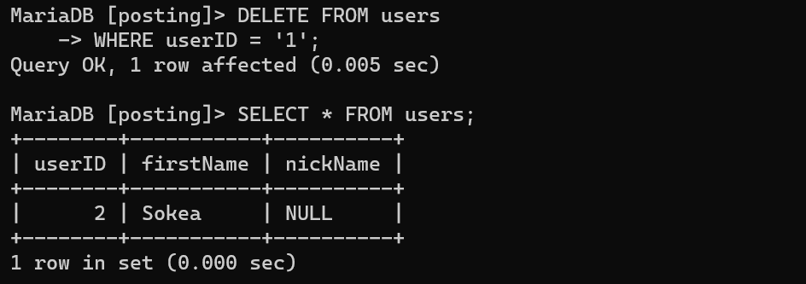

**Q9–** Add a new POST in the POST table with a userId that does not exist in the User table (ex: userID = 45)

* What’s happen? Why?
* We cannot add a new post when it FOREIGN KEY doesn’t match with any userID in users table.

